**NAAN MUDHALVAN**

**DIGITAL MARKETING**

**PARTICIPANTS:**

**AU913120104098-SUPRIYA A G**

**AU913120104096-SRI UTHRA C R**

**AU913120104020-DEVAVAISHNEE M**

**AU913120104035-INDHU PRIYA M K**

**PROJECT – 5**

**BUILDING A WEBSITE**

**Create your first website using – WIX/Canva**

# Aim:

To create a Website using – WIX/Canva

# Procedure:

**Industry Selection:**

* Research and identify the target audience and niche within the industry. Consider factors like gender, age group, sports focus, or unique selling points.
* Choose a brand name that resonates with your niche, is easy to remember, and has an available domain name for a future website

# Open Canva:

* Open canva and login to your account

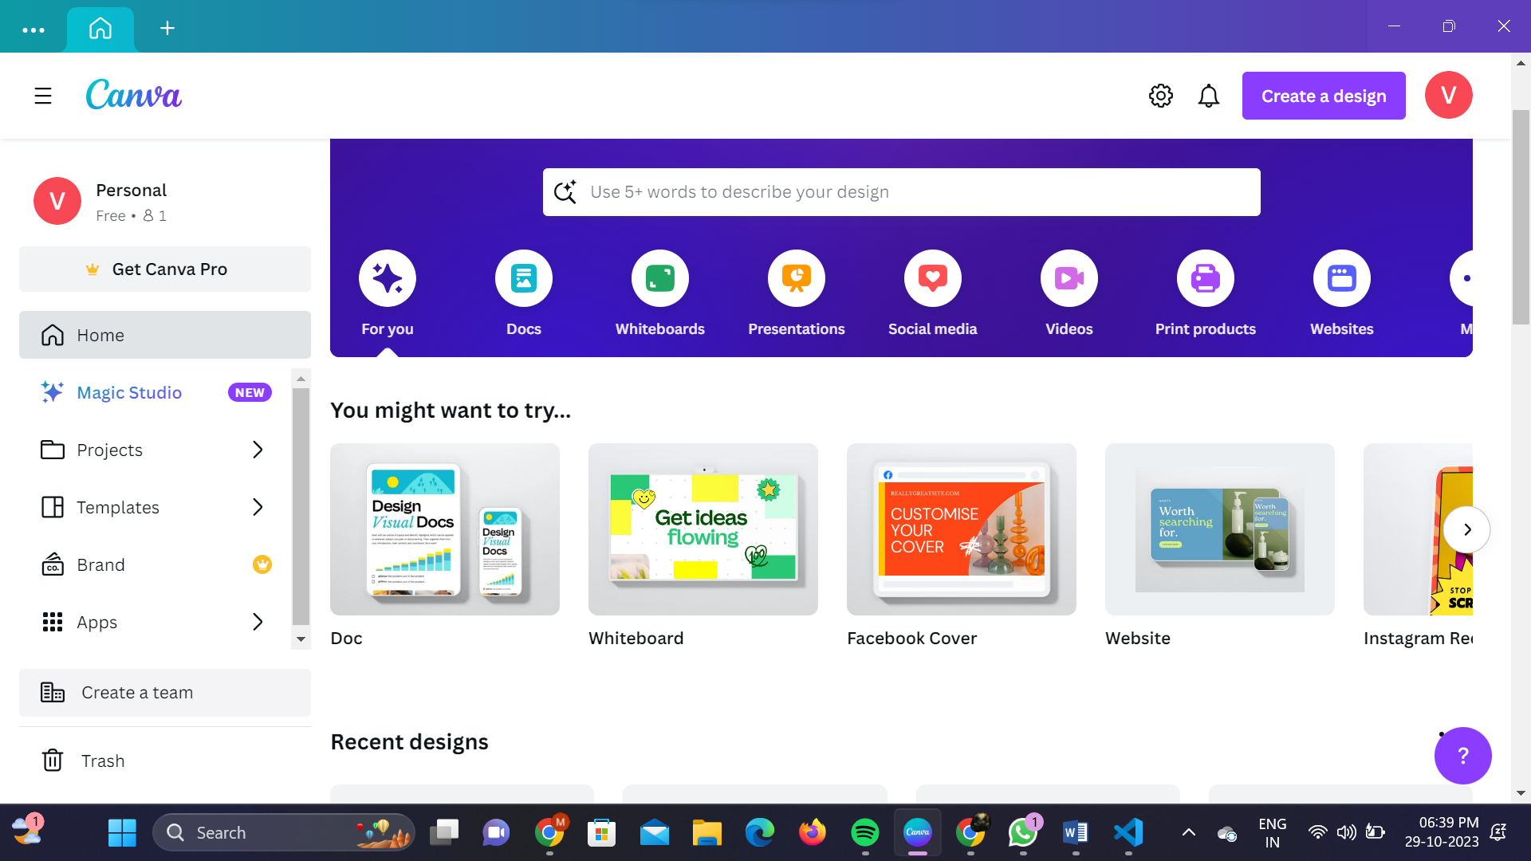

# Choose the Template:

# Choose the website template

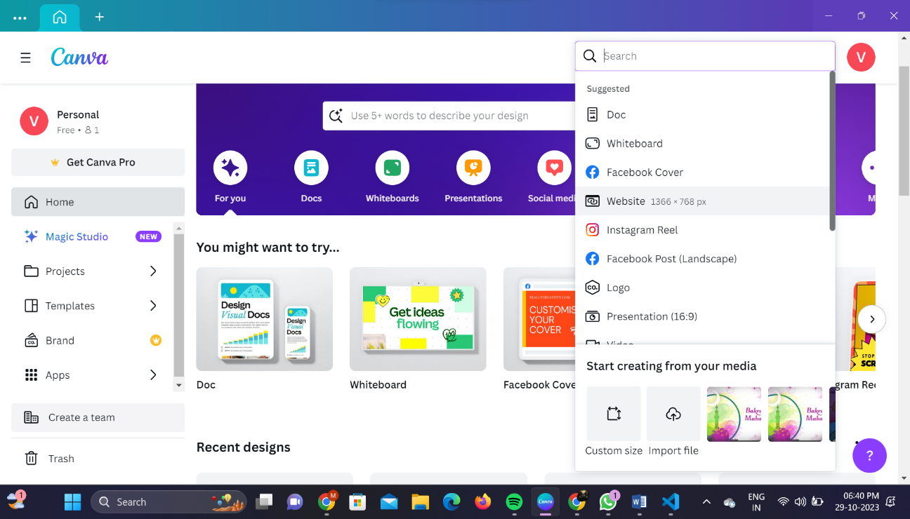

* Select the required images and text for you website

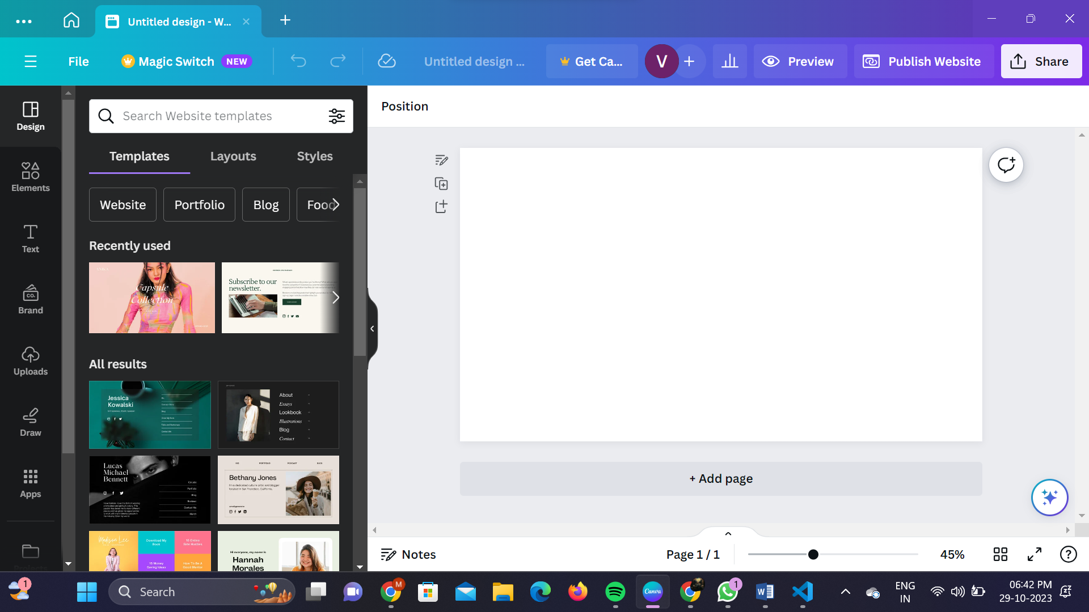

# Customize the template:

* Design your website based on your creativity

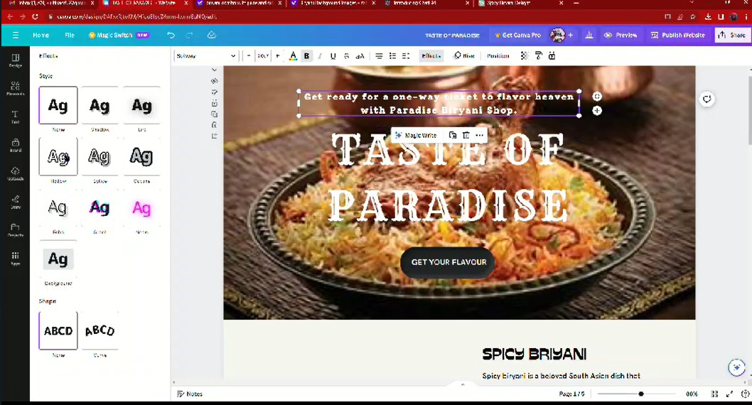

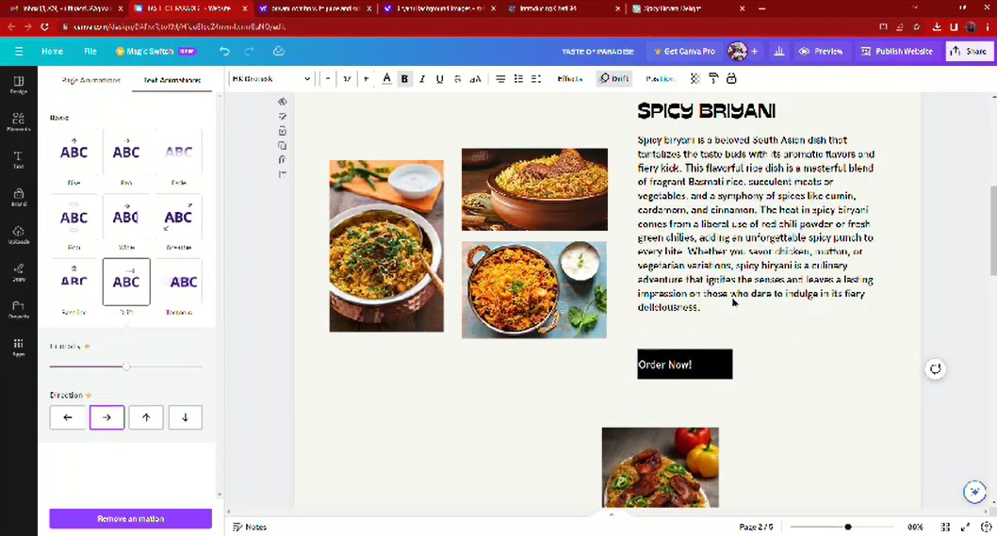

* Add some content and images to your website



* Design the webpage

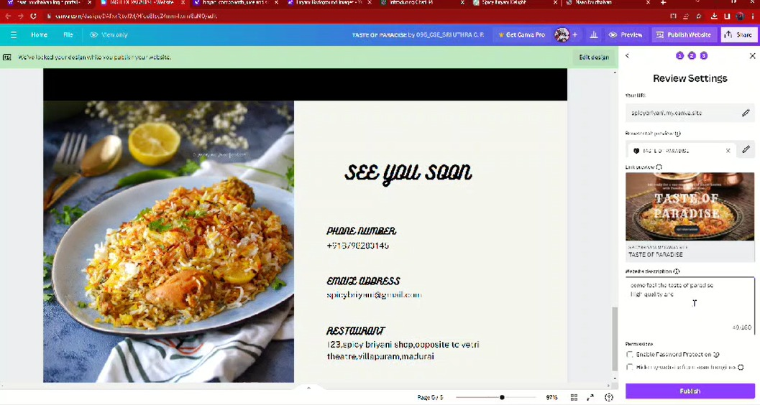

# Website:

# 

**Result**:

# Website Link:

<https://spicybriyani.my.canva.site/>

# Industry Name:

Spicy Biriyani

# Industry Type:

Restaurant

# Drive Link:

<https://drive.google.com/file/d/1Mmj_dlBzlFnVkm9gjzdj8Ug3PMjHPr2T/view?usp=drivesdk>